**BTEC Assignment Brief**

|  |  |  |  |  |  |
| --- | --- | --- | --- | --- | --- |
| **Qualification** | | | Pearson BTEC Level 3 National Foundation Diploma in Information Technology | | |
| **Unit Title** | | | 2 of 2 Develop a website to meet client requirements. | | |
| **Learning aim(s)/objective(s)** | | | In this unit you will:  C Develop a website to meet client requirements. | | |
| **Assignment title** | | | Unit 6: Website Development | | |
| **Assessor** | | | Farid Vali | | |
| **Start date** | | | 16/06/2022 | | |
| **Hand in deadline** | | | 30/06/2022 | | |
|  | | | |
| **Vocational Scenario (or Vocational Context)** | | **Scenario**  Monarch is a small business selling clocks and watches. It is currently only existing as a traditional ‘brick and mortar’ shop on the High Street in Bolton. They would eventually like to venture into e-Commerce. They would like a website which is easy to maintain, and interesting and interactive website for their prospective customers. You have been hired as a website developer to advise them about website technologies, in addition to designing and developing of their website. A website of a Multi-page, two-way interactive website. | | | |
|  | | | |
| **Task 1:** | | **Task 1 (P4, P5, P6, M3, D3)**  ***P4,***Produce a website for an intended audience and purpose.   * + Linked website including home and contact page   + Hyperlinks   ***P5,***Test the website for functionality, compatibility and usability.   * + Functionality testing for example user environments, links, navigation; content; check against user requirements;   ***P6,***Review the extent to which the website meets client requirements.   * + Text – proofread and error free   + Images – scaled and correct for website   + Formatting techniques   + Format standardisation   + Correct alignment on all pages   ***M3,***optimise the website to meet client requirements.  ***D3****,* Demonstrate individual responsibility, creativity and effective self-management in the design, development and review of the website.  **Client-side scripting languages**   * Embedding of original client-side scripts into web pages to provide more interactivity and improve the usability of the website. * Types of web-scripting languages, e.g. JavaScript®, VBScript®. * Uses of scripting languages, e.g. alerts, confirming choices, browser detection, creating rollovers, checking/validating input, handling forms. * Constructs, e.g. syntax, loops, decision making, functions, parameter passing, handling events, methods.   **Website development**  Creation of interactive websites, including:   * use of CSS, e.g. HTML tags, CSS frameworks, box model, access CSS from HTML, doc types * use of original client-side scripting * compatibility with mobile and tablet devices * effective use of tools and techniques * the uploading of files to a web server or host computer/device.   **Website review**  Reviewing interactive websites:   * quality in comparison with other similar websites * suitability for intended purpose and audience * suitability against the client’s requirements, including optimisation * legal and ethical constraints * strengths and improvements.   **Website optimisation**  Optimising an interactive website, including:   * performance and user testing * obtaining and evaluating feedback from others * checking interactivity * checking compatibility * refinements and making improvements to meet client needs to optimise the website.   **Skills, knowledge and behaviours**   * Planning and recording, including the setting of relevant targets with timescales, how and when feedback from others will be gathered. * Reviewing and responding to outcomes, including the use of feedback from others, e.g. IT professionals and users who can provide feedback on the quality of the website and their suitability against the original requirements. * Demonstrate own behaviours and their impact on outcomes to include professionalism, etiquette, supporting others, timely and appropriate leadership, accountability and individual responsibility. * Evaluating outcomes to help inform high-quality, justified recommendations and decisions. | | | |
| **Criteria covered by this task:** | | | | | |
| **Criteria reference** | **To achieve the criteria you must show that you are able to:** | | | | |
| P4 | Produce a website for an intended audience and purpose. | | | | |
| P5 | Test the website for functionality, compatibility and usability. | | | | |
| P6 | Review the extent to which the website meets client requirements. | | | | |
| M3 | Optimise a website to meet client requirements. | | | | |
| D3 | Demonstrate individual responsibility, creativity and effective self-management in the design, development and review of a website. | | | | |
|  | | | | |
|  | | | | |
| **Sources of information to support you with this Assignment** | | | **Sources of information**  **Books**  Flanagan D – JavaScript: The Definitive Guide (Definitive Guides),Sixth Edition (O'Reilly Media, 2011) ISBN 9780596805524. This is a useful guide on how to use client-side scripting within websites to produce interactivity and ultimately engaging websites.  McFarland D – CSS: The Missing Manual, Fourth Edition (O'Reilly Media, 2015) ISBN 9781491918050. An excellent book on how to use HTML and CSS to produce clean, usable websites.  UNIT 6: WEBSITE DEVELOPMENT9781446928318 – Pearson BTEC Nationals in IT – Delivery Guide Issue 1 – July © Pearson 2016 8  McGrath M – HTML5 in Easy Steps, Seventh Edition (In Easy Steps Limited, 2011) ISBN 9781840784251. This book simply conveys how to apply HTML5 scripting to websites easily and efficiently.  Bartlett K – Sams Teach Yourself CSS in 24 Hours, 3rd Edition (Sams, 2010) ISBN-10 0672331020,  ISBN-13 978-0672331022  Castro E – HTML, XHTML, and CSS: Visual QuickStart Guide, 6th Edition (Peachpit Press, 2006)  ISBN-10 0321430840 ISBN-13 978-0321430847  Cederholm D – Web Standards Solutions: The Markup and Style Handbook, 2nd Edition (FRIENDS OF ED,  2009) ISBN-10 1430219203, ISBN-13 978-1430219200  Meyer E – CSS Pocket Reference, 3rd Edition (O’Reilly, 2007) ISBN-10 0596515057,  ISBN-13 978-0596515058  Negrino T and Smith D – JavaScript for the World Wide Web, 5th Edition (Peachpit Press, 2005)  ISBN-10 0321423348, ISBN-13 978-0321423344  Pollock J – JavaScript: A Beginner’s Guide, 3rd Edition (McGraw-Hill Osborne, 2009) ISBN-10 0071632956,  ISBN-13 978-0071632959  Schmitt C – CSS Cookbook, 3rd Edition (O’Reilly, 2009) ISBN-10 059615593X, ISBN-13 978-0596155933  Shea D and Holzschlag M – The Zen of CSS Design: Visual Enlightenment for the Web (Peachpit Press, 2005)  ISBN-10 0321303474 ISBN-13 978-0321303479  Weakley R – Sams Teach Yourself CSS in 10 Minutes (Sams, 2005) ISBN-10 0672327457,  ISBN-13 978-0672327452  **Websites**  www.w3schools.com The w3schools.com website is a useful starting point for anyone who wishes to learn how to use HTML, CSS and Javascript to produce websites.  www.codecademy.com Anyone can register on the Code academy website. It includes free videos and training tutorials on how to develop websites.  https://validator.w3.org Mark-up Validation Service (W3C) allows you to validate website content for free. This enables you to check for errors and ensure that your website is W3C compliant.  www.webpagesthatsuck.com This website analyses good and poorly designed websites. You may find it useful for showing learners examples when explaining how to design clean, intuitive websites.  www.csszengarden.com The CSS Zen Garden website allows anyone to explore different CSS templates which can be applied to a website design. You could show learners different styles of website layouts and how those layouts can be achieved using CSS.  www.thebestdesigns.com  www.w3.org www.w3schools.com  www.webdesignfromscratch.com/articles-and-tutorials | | |
|  | | | |

**LEARNER ASSESSMENT SUBMISSION AND DECLARATION**

When submitting evidence for assessment, each learner must sign a declaration confirming that the work is their own.

|  |  |  |  |  |
| --- | --- | --- | --- | --- |
| **Learner name: Rowan McNally Harrison** | | | **Assessor name:** Farid Vali | |
| **Start date:** 06/06/2022 | **Hand in deadline:** 30/06/2022 | | | **Submitted on: 30/06/22** |
| **Qualification:**  BTEC Level 3 National Foundation Diploma in Information Technology (21-22) | | | | |
| **Unit name(s):**  Unit 6: Website Development | | | | |
| **Assignment title:** Unit 6 2 of 2 Develop a website to meet client requirements. | | | | |
| Please list the evidence submitted for each task. Indicate the page numbers where the evidence can be found or describe the nature of the evidence (e.g. video, illustration). | | | | |  |
| **Task reference** | | **Evidence submitted** | | **Page numbers or description** |
|  | |  | |  |
|  | |  | |  |
|  | |  | |  |
|  | |  | |  |
| Additional comments to the Assessor: | | | | |
|  | | | | |
| **Learner declaration**  I certify that the work submitted for this assignment is my own. I have clearly referenced any sources used in the work. I understand that false declaration is a form of malpractice.  Learner signature: Rowan McNally Harrison                                         Date:30/06/22 | | | | |

**Mathematics Assessment Feedback (for** **embedded mathematics)**

|  |  |  |  |  |
| --- | --- | --- | --- | --- |
| **Mathematics Assessment** | | | | |
| Chose correct calculations independently | 3  All of the time | 2  Most of the time | 1  Some correct calculations chosen independently | 0  Unable to work independently to select calculations |
| Carried out calculations accurately | 3  All of the time | 2  Most of the time | 1  Some of the time | 0  Incorrect working out. |
| Used appropriate units  (MB, GB, KB, etc.) | 3  All of the time | 2  Units used accurately throughout the work | 1  Units used accurately some of the time. Some omissions or errors | 0  Units used are incorrect or units are not shown for most calculations |
| Work is set out in a logical way which shows methods used | 3  All of the time | 2  Most of the time | 1  Some of the time. | 0  Unable to work independently to show methods and logical calculations. |
| **Total** |  |

**Written Assessment (Feedback for embedded English)**

**Level 1, 2 and over**

|  |  |  |  |  |
| --- | --- | --- | --- | --- |
| **Written Assessment** | | | | |
| Work is clear, organised and is relevant for the intended reader | 3  All of the time | 2  Most of the time | 1  Some of the time | 0  Insufficiently clear, organised or relevant |
| Format is suitable for the reader and purpose (e.g. formal / informal / letter / email / report etc.) | N/A | N/A | 1  Yes | 0  No |
| Spelling (generally) including 100 generic words list | N/A | 2  Mostly accurate | 1  Some  Accuracy | 0  Not accurate |
| Words from ‘100 key words’ for vocational area are spelt correctly. | 3  All of the time | 2  Mostly accurate | 1  Some  accuracy | 0  Not accurate |
| Punctuation (including cap letters) | 3  Mostly accurate | 2  Reasonably accurate | 1  Some accuracy | 0  Insufficient accuracy |
| Grammar (tenses, sentence structure, subject verb agreement etc.) | 3  Mostly accurate | 2  Reasonably accurate | 1  Some  accuracy | 0  Insufficient accuracy |
| **Total** |  |

|  |  |
| --- | --- |
| ***Student Name:*** | Rowan McNally Harrison |
| ***Unit:*** | Unit 6 Web Developement |
| ***Tutor Name:*** | Farid Vali |
| ***Deadline Date:*** |  |

|  |
| --- |
|  |

|  |
| --- |
| **Task 1 (P4, P5, P6, M3, D3)**  ***P4,***Produce a website for an intended audience and purpose.   * + Linked website including home and contact page   + Hyperlinks   ***P5,***Test the website for functionality, compatibility and usability.   * + Functionality testing for example user environments, links, navigation; content; check against user requirements;   ***P6,***Review the extent to which the website meets client requirements.   * + Text – proofread and error free   + Images – scaled and correct for website   + Formatting techniques   + Format standardisation   + Correct alignment on all pages   ***M3,***optimise the website to meet client requirements.  ***D3****,* Demonstrate individual responsibility, creativity and effective self-management in the design, development and review of the website.  **Client-side scripting languages**   * Embedding of original client-side scripts into web pages to provide more interactivity and improve the usability of the website. * Types of web-scripting languages, e.g. JavaScript®, VBScript®. * Uses of scripting languages, e.g. alerts, confirming choices, browser detection, creating rollovers, checking/validating input, handling forms. * Constructs, e.g. syntax, loops, decision making, functions, parameter passing, handling events, methods.   **Website development**  Creation of interactive websites, including:   * use of CSS, e.g. HTML tags, CSS frameworks, box model, access CSS from HTML, doc types * use of original client-side scripting * compatibility with mobile and tablet devices * effective use of tools and techniques * the uploading of files to a web server or host computer/device.   **Website review**  Reviewing interactive websites:   * quality in comparison with other similar websites * suitability for intended purpose and audience * suitability against the client’s requirements, including optimisation * legal and ethical constraints * strengths and improvements.   **Website optimisation**  Optimising an interactive website, including:   * performance and user testing * obtaining and evaluating feedback from others * checking interactivity * checking compatibility * refinements and making improvements to meet client needs to optimise the website.   **Skills, knowledge and behaviours**   * Planning and recording, including the setting of relevant targets with timescales, how and when feedback from others will be gathered. * Reviewing and responding to outcomes, including the use of feedback from others, e.g. IT professionals and users who can provide feedback on the quality of the website and their suitability against the original requirements. * Demonstrate own behaviours and their impact on outcomes to include professionalism, etiquette, supporting others, timely and appropriate leadership, accountability and individual responsibility. * Evaluating outcomes to help inform high-quality, justified recommendations and decisions. |

**P4 Produce a website for an intended audience and purpose.**

**Introduction**

As a web developer knowing the how websites work and how to create them are important addition to creating I need to know to design websites keeping the websites simple and interactive for customers as well as making them functional for all users on different platforms.

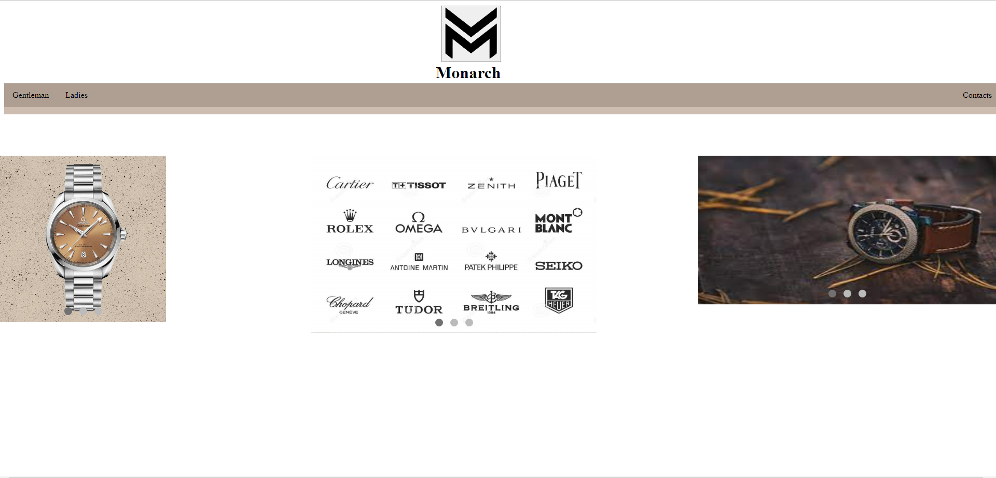

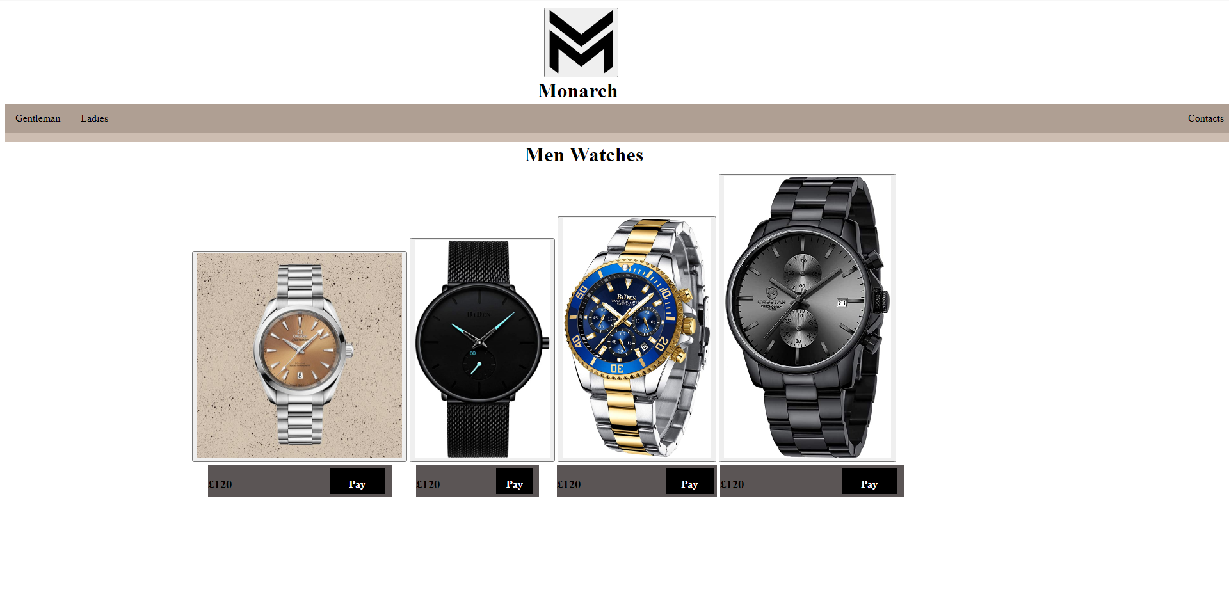

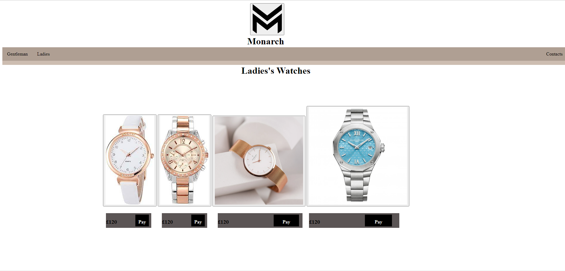

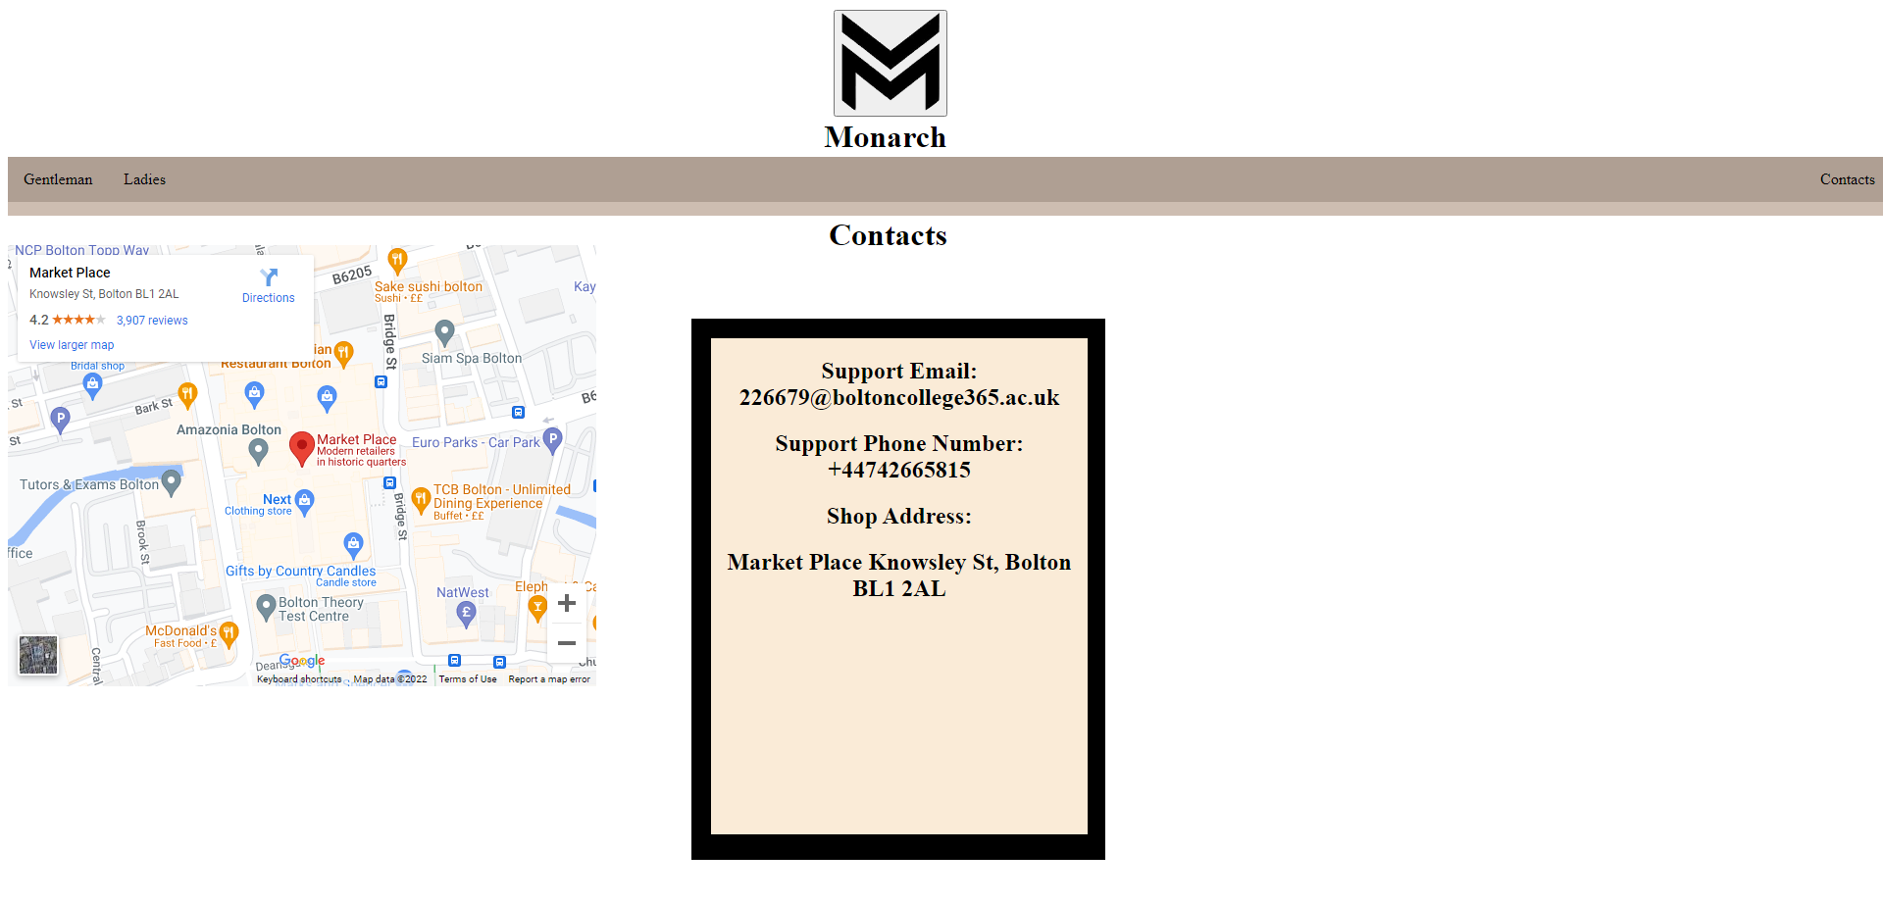

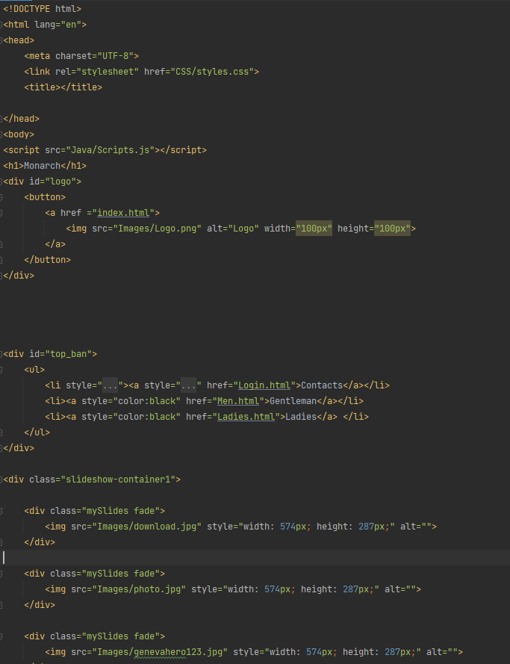

Because of JavaScript being a different coding language, I’ve also made different folder for the Java Scripts which also needs to be imported by using <script> and referencing the Scirpts.js file.

For all the CSS style to work I’ve created a separated CSS file which is imported at the top using a <link> and referencing the CSS in the CSS folder.

The div logo creates the image of the monarch logo which can be pressed on any page to get back to the main page by referencing the index.html

The Top Ban div creates the top rectangle at the top which is the menu for the buttons of Contacts, Gentleman and ladies’ button and has a style to change the texts colour to black instead of white which is the normal colour.

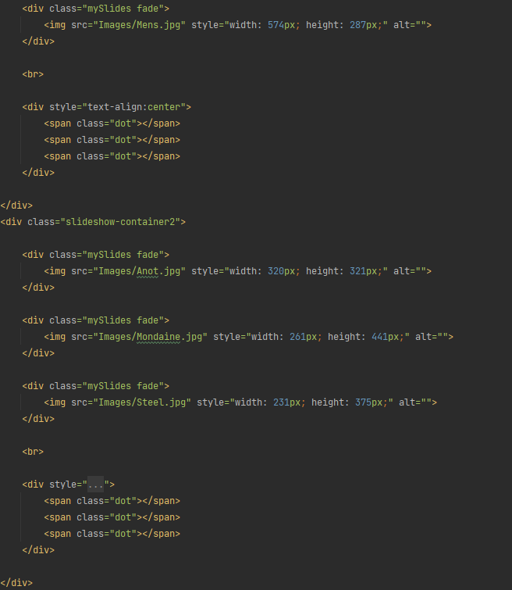

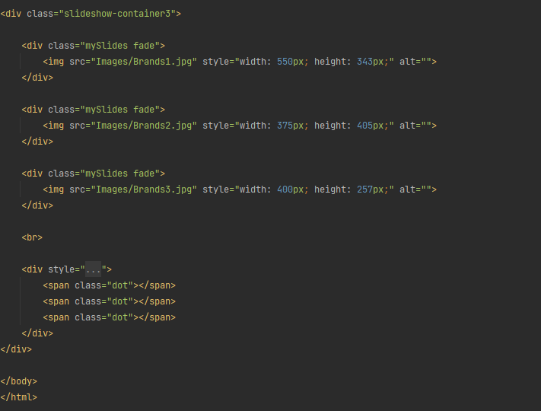

The Slideshow containers create and show the image slideshows that gets changed every 10 seconds which happens from the JavaScript files.

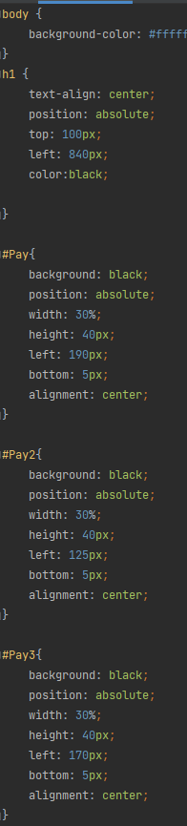

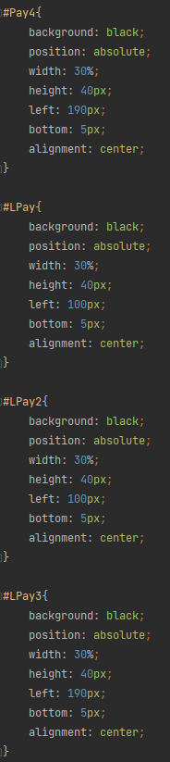

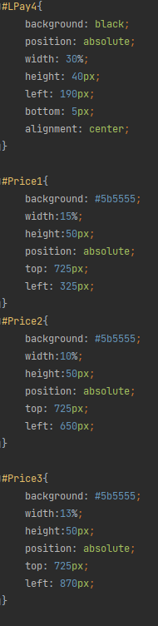

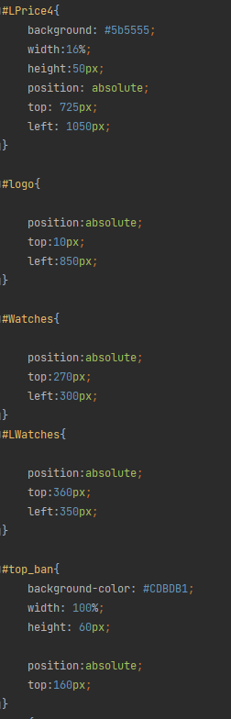

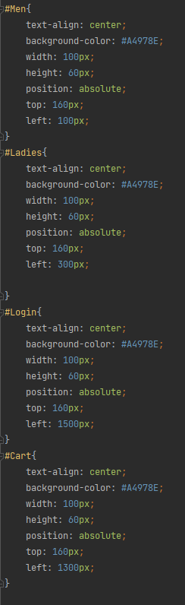

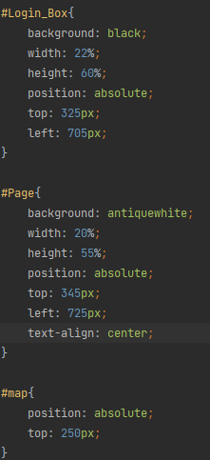  
CSS creates all of the styles in a separated file keeping the page codes small and simple to understand

With CSS I’ve used backgrounds to add colour to the pages making them for distinguishable

I’ve used width to make the boxes and rectangles have the correct looks like in the design.

Position allows the images/texts/boxes to be moved via using top/bottom/left/right using px as a measurement.

Text-align gets all the text in the ID/Class and aligns it to the left, right, top, bottom or centre.

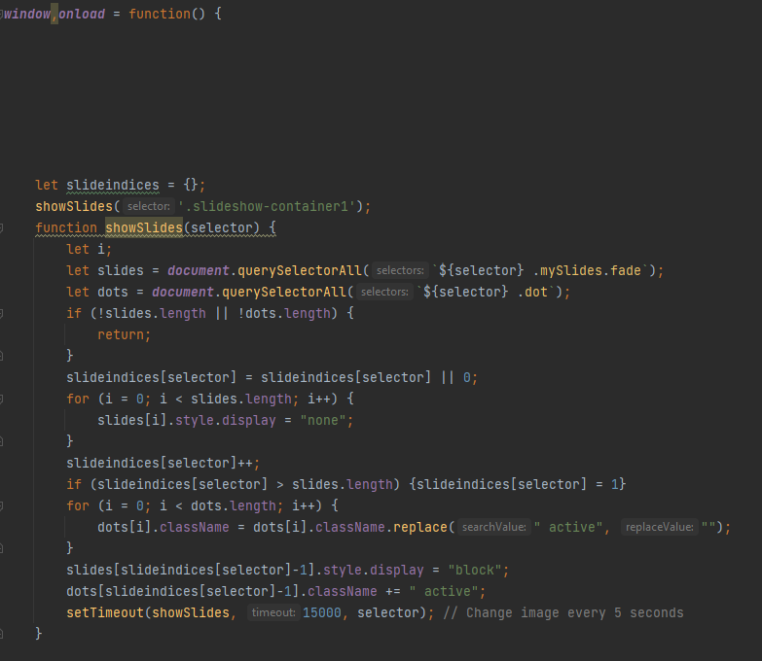

This JavaScript code is what allows the images to have a slideshow and the SetTimeOut function is what allows the timer to be set by using milliseconds so 15000 is set as 15 seconds.

The SlideIndices if statements check which image is set so if image 1 is being shown is dots at the bottom will shade the first dot and so with image 2 or 3 it will do the same and all this code will be started as the page loads because of the window,onload = function() this allows all the code to be ran at the start of the page.

***P5,***Test the website for functionality, compatibility and usability.

Main Page

|  |  |  |  |  |
| --- | --- | --- | --- | --- |
| **Test** | **What am I testing** | **Does it work** | **If not what did I change** | **Did the change work** |
| **1** | Button on the Main Page to Ladies, Men’s and Contact | All buttons to all different pages work correctly |  |  |
| **2** | Does all the images show correctly on the slide show | All images are shown every 15 seconds correctly |  |  |

Men’s Watches Page

|  |  |  |  |  |
| --- | --- | --- | --- | --- |
| **Test** | **What am I testing** | **Does it work** | **If not what did I change** | **Did the change work** |
| **1** | Clicking on the images just reopens the page | Clicking on the images takes you to the Ladies page instead of reopening the page | I changed all the href=”Ladies.html” to href=”Men.html” | Yes Changing the href’s to the correct page reopens the page |
| **2** | Clicking on the Pay button reopens the page | Clicking on the pay button take you to the ladies page instead of reopening the men’s page | I changed all the href=”Laides.html” to href=”Men.html” | Yes Changing the href’s to the correct page reopens the page |

Ladies Watches Page

|  |  |  |  |  |
| --- | --- | --- | --- | --- |
| **Test** | **What am I testing** | **Does it work** | **If not what did I change** | **Did the change work** |
| **1** | Clicking on the images just reopens the page | Clicking on the Images takes you to the ladies’ page which is correct |  |  |
| **2** | Clicking on the Pay button reopens the page | Clicking on the pay button takes you to the ladies’ page which is correct |  |  |

Contact Page

|  |  |  |  |  |
| --- | --- | --- | --- | --- |
| **Test** | **What am I testing** | **Does it work** | **If not what did I change** | **Did the change work** |
| **1** | Testing if the google maps integration allows the user to move the map around and check the Directions | Holding down CTRL + using the Scroll wheel allows the user to zoom in and out and holding down the left click button allows the to move the map around |  |  |

***P6,***Review the extent to which the website meets client requirements.

The website I have created has all the text correct and proof read with no errors in spelling or its formatting as they are all in the centre of the buttons at the top banner aligned to the left and right. All images are scaled to be small and big depending on the page like in the watch pages for ladies and men the images are at a medium scale but small enough to be on 1 page without scrolling and having the pay button underneath with the products name and on the main page the images are on the left middle and centre made as a slideshow correct for the website using all the correct formatting and standardisations.